Visitacion Valley Middle School Library
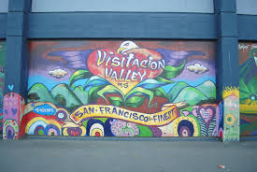
Annual Report May 2015
Teacher Librarian: Callen Taylor
Library Mission
The mission of Visitacion Valley Middle School is to inspire readers, encourage tech savvy students, and create a strong sense of community through a variety art, science, and literacy programs:
- by collection development policies that foster the acquisition of materials that present diverse perspectives and experiences, a variety of interests and reading levels, in numerous languages and with a focus on books to meet the demands of the Common Core;
- by collaborating with teachers, the Instructional Reform Facilitator and tech leads to create rigorous and engaging curriculum that will instruct students in both information literacy and general literacy;
- by creating a safe and nurturing environment so all students have a place to go to learn and relax;
- by developing a variety of library programs that engage students in the arts, science, reading to enchant students and promote a life-long fascination of reading and learning;
- by constructing a space that incorporates numerous tech tools to encourage and promote critical thinking and decision making skills.

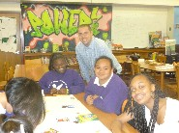
Highlights:

- Added over 900 books to the collection, with a focus on Non-Fiction Narrative
- Added many new books to the Chinese and Spanish collection.
- Increased circulation by 72%
- Initiated a Summer Reading Program.
- Cleared 98% of all 8th grader books and textbooks
- Facilitated Teen Tech Week
- Improved website by adding teacher project pages and easier access to databases
- Created areas for students: a café like setting and lounge.
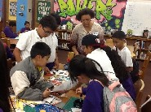
- Hosted four student book clubs, one teacher/staff book club and quarterly Book Talks with the SFPL VV branch librarian.
- Two Donors Choose Projects were funded to support book clubs.
- At the end of the year, began a Coding Club and Chess Club to start at the beginning of the year next year.

Librarian
2014-2015
- Expanded the number of books with over 900 books.
- Collection emphasis: Nonfiction Narrative Books in both Science and Social Studies.
- Created a warm and welcoming space with new furniture and art.
- Initiated a Summer Reading program by working with the ELA teachers and created a website for the project using Lib Guides.
- Hosted non-fiction book talks in the 6th grade history classes.
- Created a Literacy team to address issues of literacy, teaching and learning with the goal of making a literacy pd plan for the next school year.
- Cleared 98% of all 8th grade books and textbooks: either they turned in the books or paid for them (this does not include the 5-6 students that transferred mid year. I did get the 6th transfers though. I did a big push to get all overdue books in and was able to collect about 350 in the last two weeks alone.

Goals for 2015-2016
- Increase the high interest, low level reading books
- Have every student check out a book.
- Work with all teachers to have students check out books for the content area
- Roll out the Literacy Plan to teachers
- Host a family literacy night
- Use the Diversity Calendar I made in my SJSU MLIS class for VVMS.
- More consistent book clubs for students.
- Keep up on check out, return, repeat cycle!

Instructional Partner and Teacher
2014-2015
- TL collaborated with 10 teachers on a variety of projects that included using Destiny to write book reviews, how to use Noodletools, reading projects, and social studies research projects.
- TLs met with ELA and SS departments regularly to collaborate and support their work.
- Initiated a Summer Reading Program with the ELA teachers.
- TL modeled lessons: SFUSD Databases, Noodletools, Prezi, how to find information in a text.
- TL taught Cyber Safety classes to all students and had 2nd period Library Skills students present their own Cyber Saftey power points to the sixth grade.
- TL taught Newcomer students how to log-on, use Google Apps and Destiny.
- Implemented new technologies into my teaching: Screencasts and Guide on the Side.
Goals for 2015-2016
- TL will work with teachers to incorporate research skills into all classes all year.
- TL will encourage the use of NoodleTools to support bibliographies and citations.
- TL will work with ELA Department to promote the school wide reading program and facilitate the Literacy PLC.
- Roll out a Research Orientation for sixth and seventh grade.
- Create an online Library Orientation using Guide on the Side
- Evaluate and Improve the Summer Reading Program

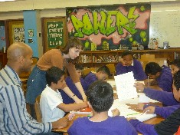
Information Specialist
2014-2015
- Created Tech team with the IRF to manage computer labs, it requests, and ipad carts.
- TL wrote newsletters informing teachers how to use and incorporate SFUSD databases into the curriculum.

Goals for 2015-2016
- Work with Tech Team to create a skill list of tech/ research skills for each grade.
- Develop pathfinders and tutorials to facilitate research and creative project completion.
- Create and implement a research orientation for 6th 7th grade.
- Update the library website

Program Manager
2014-2015
- Hosted three student book clubs (with an average of 10 students in a group) and two teacher book group, quarterly lunch time book talks with the SFPL Vis Valley Teen Librarian, and a LBGTQ Book talk for the Gay Straight Alliance.
- As a part of the Circle of Schools relationship with Salesforce, began a Coding Club with 6th graders.
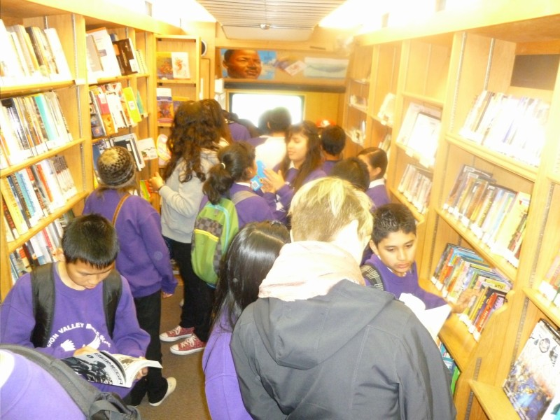
- Teen Tech Week- with lunchtime activities.
- Monthly lunch activities: button making with SFPL, drawing Bone competition with Comix Experience
- 40 Book Challenge:
75 students participated
14 students completed the challenge!

Goals for 2015-2016
- Host more book clubs for students and teachers
- Start the ebook at lunch program
- Continue to support clubs at lunch, especially a chess club
- Host the Book Mobile and library card drive.
- Have author talks

Leader
2014-2015
- TL was a computer lab manager and tech team co-facilitator
- Facilitated an ELL pd about how to address the needs of the Long Term ELLs

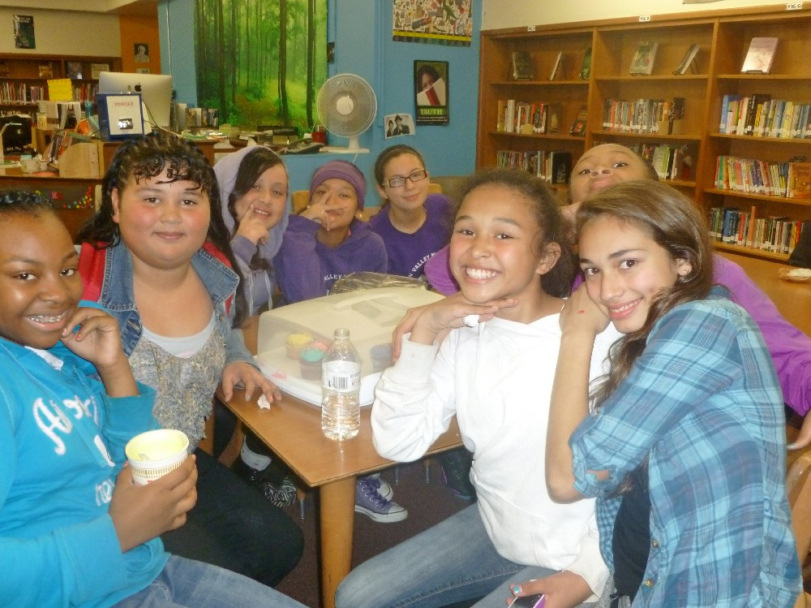
Goals 2015-2016
- Continue work on ILT and Tech Teams
- Facilitate PDs on incorporating research skills into the classroom everyday (yes! Everyday)
- Lead the Literacy Team to help implement literacy goals and pds.
- Mentor a teacher

Professional Development
2014-2015
- Attended the YALSA, CSLA
- Continue to work with Michelle Powers on pds that promote research skills.

Goals for 2015-2016
- Work with other TLs on collaborative projects

Challenge Areas:
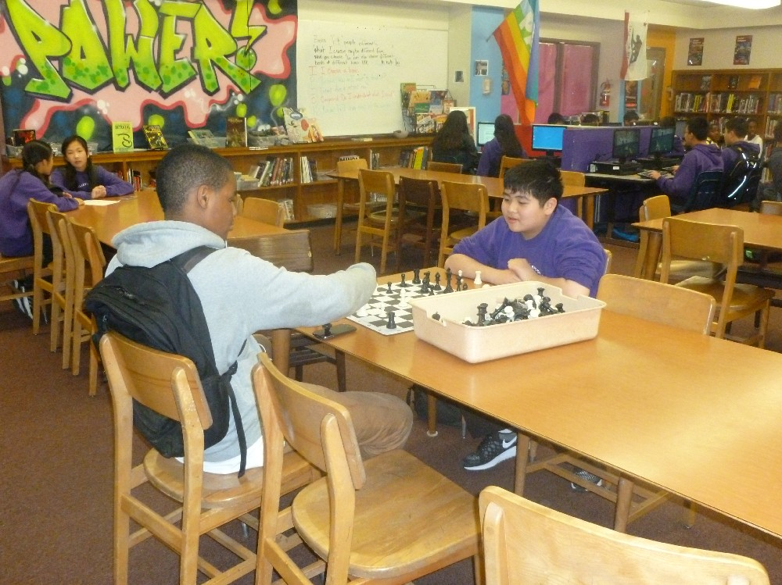
This year I worked one more day but felt like I did less. When writing this report I was curious to why I worked with fewer teachers, facilitated fewer PDs and was less active in the Instructional Leadership Team. Last year, VVMS had an IRF that I worked closely with. Together we worked on meaningful collaborations with teacher and projects. This year that IRF became and AP and was not able to commit on a regular basis on projects. The school did not get an IRF this year and I think I filled in for the IRF in many aspects and not all of those responsibilities were library related. I was pulled in many directions this year and unable to work deeply on any project. I want to prune some of the extra work next year and focus on two areas: research and literacy.
Another challenge next year will be the school remodel. I will need to box up the library for the remodel in the fall. I have four rooms I am responsible for and I am cannot even visualize how this will work.

Lastly, I tried a few literacy initiatives: 40 Book Challenge, Summer Reading, Book Clubs and to get teachers to read and suggest a book to students. The programs started well but kind of fizzled without teacher support. I could not be a one-woman show and really needed teacher support in promoting and sustaining these initiatives.

Library Statistics
Circulation
 | 2012-2013 | 2013-2014 | 2014-2015
Total Yearly Circulation | 295 | 3,229 | 5,678
Books Added | 259 | 1837 | 958
Books Deleted and Weeded |  | 6,915 | 1319

Library Usage
Average students served per week: 535 students
Collaborative Research Projects and Units
- Music Heritage Research Project
- Islam Research Project
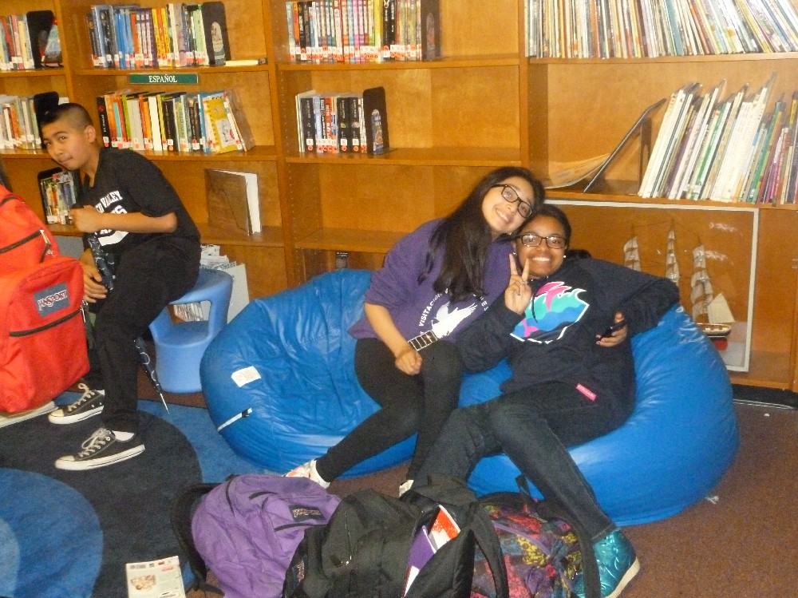
- Ancient Religion Webquests
- Writing book reviews for Destiny
- Annotated Holocaust Picture
- Chew on This libguide
Co-Teaching/ Modeling work:
- Using Instagrok to presearch
- How to use Noodle Tools

Subscription Database Usage
 | 2012-2013 | 2013-2014 | 2014-2015
Culture Grams | 17 | 204
World Book Online | 12 | 2346 | 1,736
Noodle Tools | 0 | 346 | 436
SIRS | 0 | 1147 | 142
Britannica |  |  | 2642
# of Libguides |  | 10 | 12

Budget

School Budget
Category | 2014-2015  Requesting | PO #  2014-15 | Rationale
Reading Materials  -Jr. Library Guild  -Magazines:  -Books  -Ebooks | $1414,20  $296.57  $5,000  $500 | JLG- 868-lib04-1415  1701.00  Magazines  $323.31  868-lib05-1415  Titlewave:  Libo5- $1533.61  Lib06  $1207.11  Lib07  $1558/05 | I will continue the subscriptions to the JLG and magazines. I want to expand the newcomer collection and the diverse book collection. As per teacher suggestion I want to work on the biography and ancient history collections to meet the demands of the common core
Supplies | $1000 |  | Supplies include cataloguing, book binding, and other supplies necessary to keep up the library.
Lunch and Clubs | $339  $2500 | Games- S&S supplies  410.79  868-lib03-1415  Lego Robotics  868-Lib08-1415  $1,967.34 | I need to replace games from last year. The additional $2500 is to create a LEGO robotics and story club. They are educational kits that can be used in the library or in classes.  - National Geographic Bee registration  - 50 Book Challenge awards
Environment | $1937  $500 |  | I would like two rugs and few bean bag chairs to complete the café sections and some funds for prints.

PEEF: $13,040- all spent on books

